**Django-ERP User Manual**

**Sales Management**

## A quotation

### 1.1 Business Introduction

The quotation is used for quotation approval, and the system supports importing quotation details from Excel.

### 1.2 Interface Description

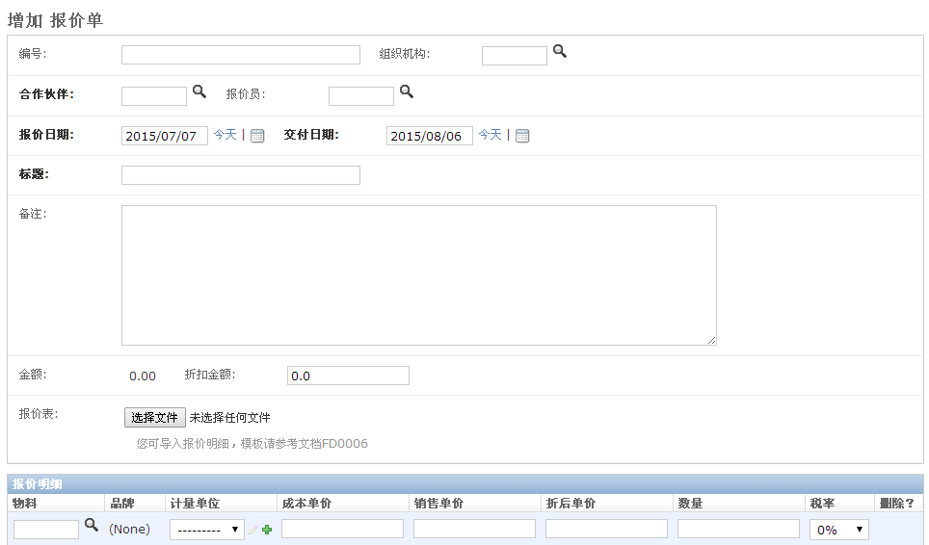

* **Quotation Master Document**

[Number]: Document number, automatically generated for retrieval

【Organization】: Select the organization to which this quotation belongs

【Partner】: Please select a customer

【Quoter】: Default is the currently logged in user

【Quote Date】: Default is the current date

30 days after the current date , which can be adjusted

【Title】: A brief description of the quotation

【Remarks】：Detailed description of the quotation

【Amount】: Automatically calculated based on the quotation details

Discount Amount: The discount amount based on the total amount. Actual total price = amount - discount amount. The system automatically calculates the discounted unit price based on the discount amount and automatically allocates the discount amount to each product in proportion.

[Quotation Sheet]: If there are too many quotation details, you can import the details from Excel. For the template, please refer to FD0006

* **Quote Details**

【Material】: Select a material from the material library, and the system will automatically display the cost price

【Brand】: Content imported from Excel

【Unit of measurement】: Select the unit of measurement for the material

【Cost Unit Price】: Enter the cost unit price of the material, for internal reference

【Unit Price】: Price quoted to customers

[Discounted unit price]: The discounted unit price automatically calculated based on the discount amount

【Tax rate】: Select the tax rate of the material

### 1.3 Operation Instructions

* **Step 1: Fill out the form**

According to the prompts on the interface, enter the required data and click the [Save] button to save the data.

* **Step 2: Submit documents**

If the quotation is configured with an approval process, you can click the [Submit] button to enter the approval process;

## 2. Sales Order

### 2.1 Business Introduction

Sales orders are used to record each sales order of the company, record the contract amount and sales materials or services, and facilitate tracking of sales proceeds and analysis of goods turnover.

### 2.2 Interface Description

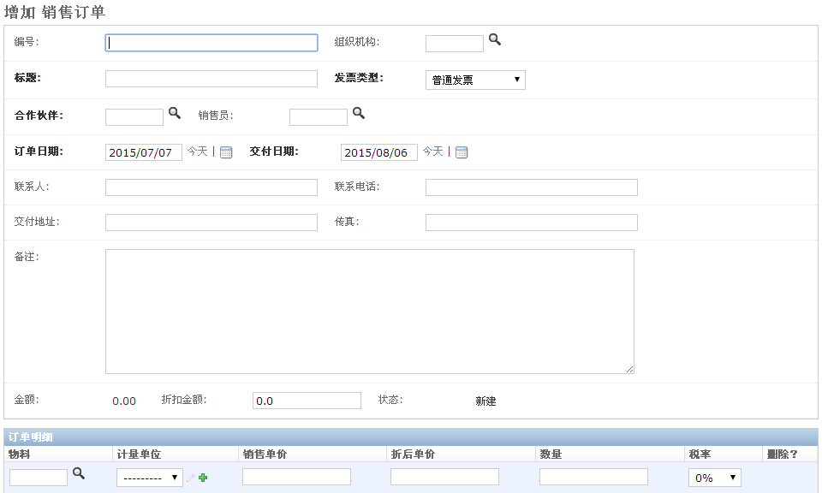

* **Sales order master document**

[Number]: Sales document number, automatically generated for retrieval

【Organization】: Select the organization to which the sales order belongs

【 Title 】: Enter a brief description of the sales order

[Invoice Type]: Select the appropriate invoice type

【Partner】：Select trading customers

[Salesperson]: Default is the currently logged in user

【Order Date】: Default is the current date

【Delivery Date】: The default is 30 days after the current date

【Contact Person】: Enter the customer's contact person

【Contact number】: Enter the customer's contact number

【Delivery address】: Enter the customer's delivery address

【Fax】: Enter the customer's address

【Remarks】: Enter other important information

【Amount】: Automatically calculated based on order details

[Discount amount]: Enter the discount amount on the total amount. Actual amount = amount - discount amount. The discount amount will be allocated to each product in proportion and the discounted unit price will be automatically calculated.

【Status】: Update according to process status

* **Sales order details**

【Material】: Select a material from the material library

【Unit of measurement】: Select the unit of measurement for the material

【Sales Unit Price】: Enter the sales unit price

[Discount unit price]: Automatically calculated discount unit price

【Quantity】: Enter the quantity required by the customer

【Tax rate】: Select an appropriate tax rate

### 2.3 Operation Instructions

* **Step 1: Fill out the form**

According to the prompts on the interface, enter the required data and click the [Save] button to save the data.

* **Step 2: Submit documents**

If the sales order is configured with an approval process, you can click the [Submit] button to enter the approval process;

## 3. Sales Collection

### 3.1 Business Introduction

Record every payment received from sales documents and calculate accounts receivable in real time

### 3.2 Interface Description

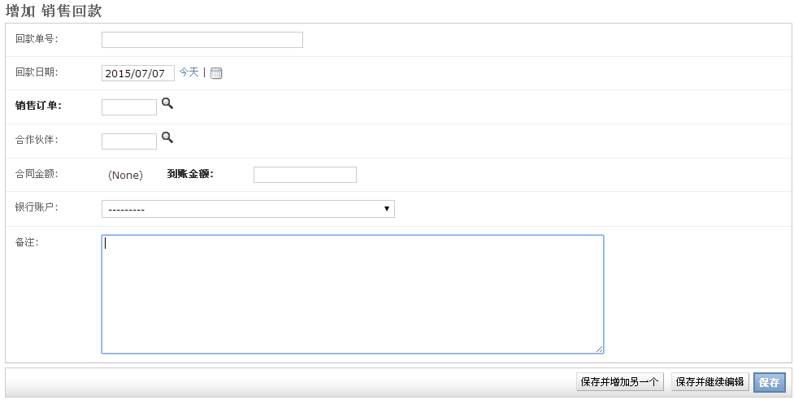

[Payment receipt number]: Serial number, automatically generated, for retrieval

【Payment Receipt Date】: Enter the actual payment date

【Sales Order】: Select the sales order corresponding to the payment

【Partners】: Information automatically displayed

[Contract Amount]: Information automatically displayed

[Amount received]: Enter the actual payment information

【Bank Account】: Select the bank account to receive the payment

【Remarks】: Enter the remarks information

### 3.3 Operation Instructions

* **Step 1: Fill out the form**

According to the prompts on the interface, enter the required data and click the [Save] button to save the data.

* **Step 2: Submit documents**

If the payment collection is configured with an approval process, you can click the [Submit] button to enter the approval process;